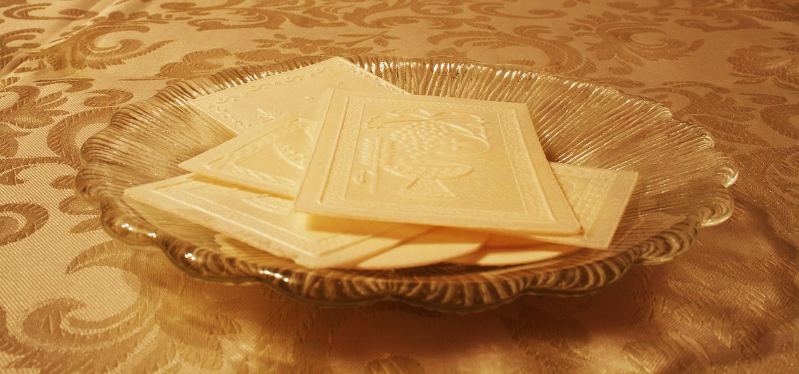

# OPŁATEK DINNER

# DANCE

## **January 7th, 2017**

## $25/person - $15/student Children under 7 free

## Doors open at 6:00 p.m.

## Polish School Children perform 6:30 p.m.

Dinner starts at 7:30 p.m.

Music by JANTAR (DARIUS)

Tickets available at the rectory, Polish Credit Union & Polska Chata or call Jan @ (585) 729-7878

